**Executive Summary**

This is the project plan of Code Similarity Comparer by Team HW. This report specifies the requirement, methodology, hardware and software resources, project life cycle.

This report is divided into eight parts. The first part is about summary of the project including stakeholders and objectives. The second part is the methodology summary which defines the organization structure. The third part introduces the project’s hardware and software resource requirements. The forth part shows the project’s Work Breakdown Structure following the fifth part which is our project schedule in the form of Gantt Chart. The sixth and seventh part are the specification of configuration management and documentation template. The last part is this project plan summary.

**I Introduction**

Code Similarity Comparer (CSC) is developed which provides numerical values to represent the similarity between two pieces of source code in C. After a user submit two files (namely original file and target file), CSC will generate four double values which represents four types of degree of similarity.

The project is functionally an assignment of Course CS3343 offered by Department of Computer Science in City University of Hong Kong in Semester B, 2012 to 2013. It can be only used for academic purpose and the copyright is reserved by Team HW.

1. Stakeholders

|  |  |
| --- | --- |
| Stakeholder | Description |
| Team HW | Project team |
| Dr. Chan | Project Supervisor |
| Dr. Keung | Project Supervisor |
| Software Quality Management Students | People who help improve the project |

1. Project Objectives

* To provide the similarity between two pieces of source code
* To indicate the degree of potential plagiarism between two pieces of work
* To practice software engineering skills during each step in the life cycle
* To get A+ in CS3343 project assessment

**II Summary of the methodology**

1. Software Development Methodology

Agile Development Approach is adopted for project development. Detailed agile principles are appended at the end of project plan.

Object-oriented programming paradigm, Java SE 6 is required throughout the development of our project.

1. Project Team Organization

Among each cycle, the list of software engineering roles are assigned to different team members but the organizational structure remains the same. Within each cycle, every team member belongs to each functional group and managers only take charge of the controlling process.

Cycle 1

|  |  |  |  |  |
| --- | --- | --- | --- | --- |
| Team Member | Student ID | Nickname | Position | Responsibility |
| YUAN Siyan | 52165652 | Coffee | Project Manager | Plan, coordinate, motivate and oversee the project |
| ZHANG Yanlin | 52209131 | Benson | Assistant PM | Make decisions whenever PM is offline |
| WANG Mengqing | 52209388 | Jenny | Configuration Manager | Configuration Methodology, version control |
| DUAN Huayi | 52208539 | Gavin | Development & Test Led | Code, test and debug |
| CHAN Ka Kin | 52710449 | KK |  |  |
| YEUNG Kin Wai | 52716792 | Bill |  |  |

Cycle 2

|  |  |  |  |  |
| --- | --- | --- | --- | --- |
| Team Member | Student ID | Nickname | Position | Responsibility |
| CHAN Ka Kin | 52710449 | KK | Project Manager | Plan, coordinate, motivate and oversee the project |
| WANG Mengqing | 52209388 | Jenny | Assistant PM | Make decisions whenever PM is offline |
| YEUNG Kin Wai | 52716792 | Bill | Configuration Manager | Configuration Methodology, version control |
| ZHANG Yanlin | 52209131 | Benson | Development & Test Led | Code, test and debug |
| YUAN Siyan | 52165652 | Coffee |  |  |
| DUAN Huayi | 52208539 | Gavin |  |  |

**III Hardware and Software Resource Requirements**

All the development of the project follows the hardware and software resource requirements including documentation and management. Any unexpected resource might cause serious error, or even crash the project.

|  |  |
| --- | --- |
| **Item** | **Requirement** |
| **Operation Platform** | Windows 7 64-bit |
| **Development Platform** | Windows 7 64-bit |
| **Development Tool** | Eclipse IDE 3.6.1(Windows 64-bit) |
| **Code Language** | JAVA SE 6 |
| **Code Documentation and Comment** | JavaDoc & JAutoDoc 1.9.0 |
| **Version Control** | SVN server: Google Code; SVN client: Subclipse & TortoiseSVN |
| **Test Tool** | JUnit, EclEmma |
| **Documentation Tools** | MS Office Word, Excel PowerPoint and Project |
| **Documentation Deliverables** | PDF & DOC |

IV Work Breakdown Structure

The work breakdown structure shows all the tasks in the project scope. It includes both the deliverables of the project and the project related work needs to be done.

**V Project Schedule**

The whole project starts on 18 January 2013. So far the progress has reached Iteration 2 and release 1 will be delivered. The more milestones we meet, it’s more possible for us to finish the project. The objectives of the project schedule are to complete the project with best time, least cost and least risk. Here is the Gantt Chart table and for Gantt Chart Schedule, please refer to Project Gantt Chart.

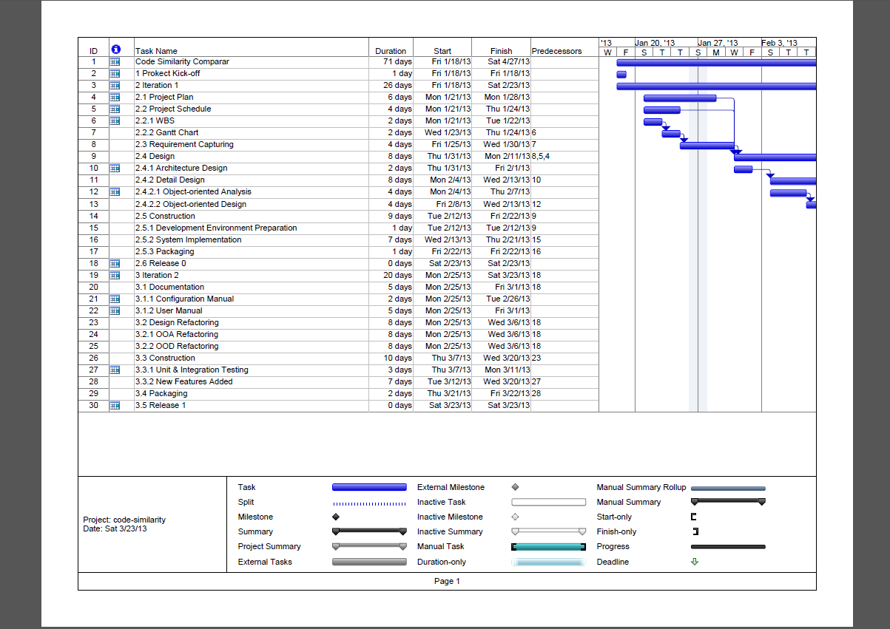

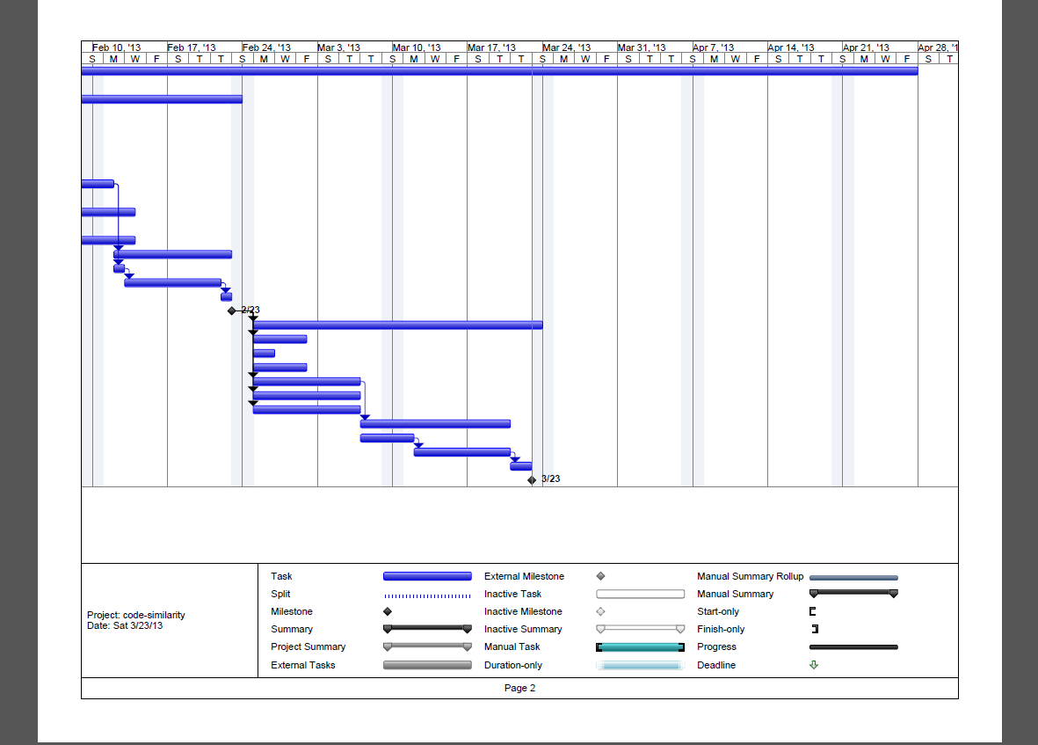

|  |  |  |  |  |
| --- | --- | --- | --- | --- |
| Task Name | Duration | Start | Finish | Predecessors |
| Code Similarity Comparar | 71 days | Fri 1/18/13 | Sat 4/27/13 |  |
| 1 Project Kick-off | 1 day | Fri 1/18/13 | Fri 1/18/13 |  |
| 2 Iteration 1 | 26 days | Fri 1/18/13 | Sat 2/23/13 |  |
| 2.1 Project Plan | 6 days | Mon 1/21/13 | Mon 1/28/13 |  |
| 2.2 Project Schedule | 4 days | Mon 1/21/13 | Thu 1/24/13 |  |
| 2.2.1 WBS | 2 days | Mon 1/21/13 | Tue 1/22/13 |  |
| 2.2.2 Gantt Chart | 2 days | Wed 1/23/13 | Thu 1/24/13 | 6 |
| 2.3 Requirement Capturing | 4 days | Fri 1/25/13 | Wed 1/30/13 | 7 |
| 2.4 Design | 8 days | Thu 1/31/13 | Mon 2/11/13 | 8,5,4 |
| 2.4.1 Architecture Design | 2 days | Thu 1/31/13 | Fri 2/1/13 |  |
| 2.4.2 Detail Design | 8 days | Mon 2/4/13 | Wed 2/13/13 | 10 |
| 2.4.2.1 Object-oriented Analysis | 4 days | Mon 2/4/13 | Thu 2/7/13 |  |
| 2.4.2.2 Object-oriented Design | 4 days | Fri 2/8/13 | Wed 2/13/13 | 12 |
| 2.5 Construction | 9 days | Tue 2/12/13 | Fri 2/22/13 | 9 |
| 2.5.1 Development Environment Preparation | 1 day | Tue 2/12/13 | Tue 2/12/13 | 9 |
| 2.5.2 System Implementation | 7 days | Wed 2/13/13 | Thu 2/21/13 | 15 |
| 2.5.3 Packaging | 1 day | Fri 2/22/13 | Fri 2/22/13 | 16 |
| 2.6 Release 0 | 0 days | Sat 2/23/13 | Sat 2/23/13 |  |
| 3 Iteration 2 | 20 days | Mon 2/25/13 | Sat 3/23/13 | 18 |
| 3.1 Documentation | 5 days | Mon 2/25/13 | Fri 3/1/13 | 18 |
| 3.1.1 Configuration Manual | 2 days | Mon 2/25/13 | Tue 2/26/13 |  |
| 3.1.2 User Manual | 5 days | Mon 2/25/13 | Fri 3/1/13 |  |
| 3.2 Design Refactoring | 8 days | Mon 2/25/13 | Wed 3/6/13 | 18 |
| 3.2.1 OOA Refactoring | 8 days | Mon 2/25/13 | Wed 3/6/13 | 18 |
| 3.2.2 OOD Refactoring | 8 days | Mon 2/25/13 | Wed 3/6/13 | 18 |
| 3.3 Construction | 10 days | Thu 3/7/13 | Wed 3/20/13 | 23 |
| 3.3.1 Unit & Integration Testing | 3 days | Thu 3/7/13 | Mon 3/11/13 |  |
| 3.3.2 New Features Added | 7 days | Tue 3/12/13 | Wed 3/20/13 | 27 |
| 3.4 Packaging | 2 days | Thu 3/21/13 | Fri 3/22/13 | 28 |
| 3.5 Release 1 | 0 days | Sat 3/23/13 | Sat 3/23/13 |  |

**VI. Configuration Management**

Configuration Management controls any change to the project including computer programs, documentation, data and development tools. The management is responsible by the configuration manager. It ensures that the descriptions of the project’s products are correct and complete.

Any changes to the code should be commented with the name of the programmer and the time of modification time as well as some remarks. All the codes are uploaded to the Google Code project management tool. Every team member can access it through SVN supplied by Google Code. Every new version uploaded to SVN should be logged with necessary remarks. Any changes out of the project scope should be reported to Configuration Manager.

|  |  |  |
| --- | --- | --- |
| Version | Release 0 | Release 1 |
| Project Plan | Ver. 1 | Ver. 2 |
| OOA | Ver. 1 | Ver. 2 |
| OOD | Ver. 1 | Ver. 2 |
| Configuration Manual | None | Ver. 1 |
| User Manual | None | None |
| Java Code Standard | Ver. 1 | Ver. 1 |
| Test Plan | Ver. 1 | Ver. 2 |
| Release Summary | Ver. 1 | Ver. 2 |
| Code Refactoring Report | None | None |
| Deliverable Guide | None | None |
| Test Specification | None | Ver. 1 |
| Program | Release 0 | Release 1 |
| Source Code | Ver 0.00 | Ver 1.00 |
| Test Code | Ver 0.00 | Ver 1.00 |
| Java SDK | SE 6 | SE6 |
| Operation Environment | Windows 7 | Windows 7 |
| Development Environment | Windows 7 | Windows 7 |
| JUnit Framework | Ver. 4.0 | Ver. 4.0 |
| Bug Report | None | Ver. 1 |
| Eclipse IDE | Ver. 3.6.1 | Ver. 3.6.1 |

**VII. Documentation Template**

**VIII. Summary**

This project plan specifies the project objectives, methodologies and the scope of the project as well as our schedule.